Instructions for joining a team:
- Visit https://teams.teamplus.education and create a new user account.
- Click the blue button that says "Join a Team Now":

- Fill out the form (example below) to select the proper course, section, instructor, and team #. In this example, the student has selected team #3, but you will choose the team # that you've been assigned. Once the form is complete, click the "Join Team" button.
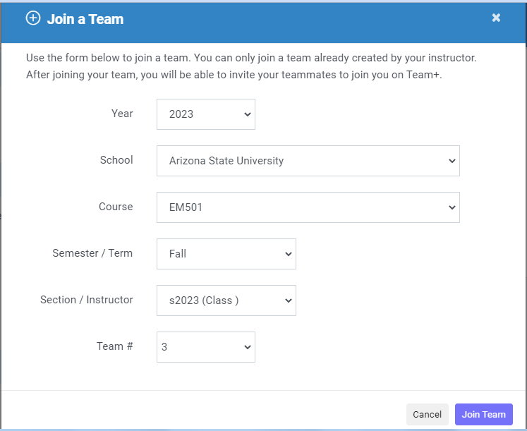
- Click the Personal Profile EDIT PROFILE button to start the first activity. See the example below. Each subsequent activity will become active button when a) You've completed the prior activity and b) the start date has arrived. You will need to complete the required Personal Profile and Team Styles activities before Team Identity becomes available.
