Improve the Performance
of Your Student Teams.

Instructor’s Guide
for
The Team+ System

MORE LEARNING. LESS HASSLE. TEAMS THAT WORK.

Introduction

Based on published research on effective student teams, as well as our own classroom experiences teaching with teams, we have designed a web-based system that helps student teams be more productive, collaborative, and successful. Independent research studies show that using the activities and methods in the Team+ system is more effective than using other peer evaluation and team development tools, such as CATME.

The Team+ System can be used in any class regardless of course content, and in both virtual and face-to-face formats. This Guide is designed to help you seamlessly integrate the Team+ System into your course.

For easy reference, see the following topics for more information.

Benefits of Using Team+

How to Get Started with the Team+ System

Team+ Implementation Checklist for Instructors

Understanding the Team Builder

What Your Students Will Be Doing: The Eight Activities

Monitoring the Performance of Your Students and Teams

Additional Features of the Team+ System

If you would like to explore Team+ in more detail prior to implementing it, feel free to access the Team+ Demo System. The Demo System allows you view a sample of the Team+ System from the perspective of a student or instructor. Feel free to explore and click through as much as you’d like in the Demo System.

We also have a Test System available if you’d like to create a Test user account and experiment with the process of account creation, setting up a test course, sending test invitations to students, creating a test student user account, and using the rest of the functionality of the system for testing purposes. Please don’t hesitate to contact support@teamplus.education with any questions or help you may need.

Benefits

How You and Your Students Will Benefit From The Team+ System

Educational research clearly shows students can benefit from “group work” in the classroom – increased motivation to learn, greater goal-oriented effort, more positive attitudes about the subject matter and the class are just a few of the many positive outcomes.

So, what’s the problem?

Rarely is teamwork the primary focus of a course. Many instructors are not interested in teaching teamwork skills. Yet, the ability to work effectively with others will significantly impact students’ success in the course. Left to work on their own, many students encounter poor group experiences. With little guidance to aid team development, student groups face many challenges, including…

- Identifying team member roles and responsibilities
- Agreeing upon group processes
- Planning and coordinating task-related activities
- Managing interpersonal conflicts
- Ensuring full participation by all team members

The Team+ System benefits both students and instructors by helping student teams overcome these challenges. Students participate in a series of activities carefully designed to promote:

- Full participation by all team members - Reduce social loafing!

- Communication and collaboration

- Planning and coordination

- Individual student accountability

- Greater team cohesion

With less conflict, more efficiency, and increased collaboration your teams can focus more on learning course content. By supporting the development of your teams, you will spend less time fielding student complaints and actually find more time to focus on teaching course content.

Additionally, the unique Team+ Instructor App allows you to monitor the participation of individual team members as well as the performance of teams. Self and peer student performance ratings are also available for download and further analysis, to help you quickly assess who is doing well and who is not.

Getting Started

The Team+ System is a web application that is accessed entirely online on the Team+ website. Follow these 3 easy steps to get started:

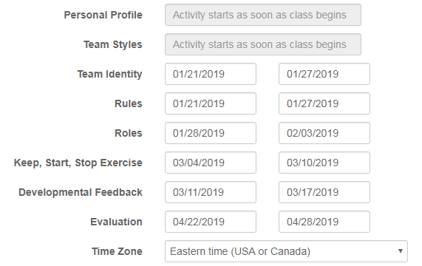
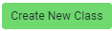
Instructor Checklist

What You Can Do to Help Your Teams Be Successful

Research clearly shows students have a more positive view of “group work” when they believe the instructor fully and actively supports the development of teamwork skills. Otherwise, it may be viewed as a sink-or-swim experience where the students see the need for collaboration as an obstacle to individual performance.

Based on published research, classroom experiences, and the feedback of instructors using the Team+ System, we can offer these tips:

- Don’t just assign Team+ and then forget about it – your students will likely fail to understand WHY they are being asked to complete these activities.

- Include a section in your syllabus about the Team+ System (we offer a sample Syllabus Insert, available here).

- During the first class meeting, take a few minutes to “introduce” the Team+ System. Share with your students the importance of teams-based learning in the classroom (and the many ways they can benefit – if helpful, we can develop an outline for you to use to discuss these benefits). We also offer a sample Team+ Overview document that can be used to introduce the Team+ System to your students, available here.

- Review the major components of the Team+ System with your students early in the semester, focusing on the 8 activities the teams will complete (The Team Builder Activities)

- Inform your students of the deadlines set for each of the activities (that is, the “window” each activity is open for completion).

- Be sure your students understand you will monitor their individual participation and team performance throughout the activities.

- Explain how their successful completion of the activities will impact their course grade (for example, participation may account for 5% of the grade in the class).

In the following pages we review each of the Team Builder Activities - the eight activities your teams will complete. As each activity closes, we STRONGLY encourage you to “bring it into the classroom” to show your support for their team development. That is, we suggest ways to explore the decisions your teams have made in each activity with possible discussion questions or exercises.

Remember, your students may not fully understand the value of these collaborative assignments – they may view them as just more “busy work.” Help them see the importance and benefits of teamwork in the classroom. As their instructor showing your support of the Team+ activities is a major factor in the adoption and positive impact of the system.

Team Builder

Individual and Team Data is Displayed on the Team Builder Page

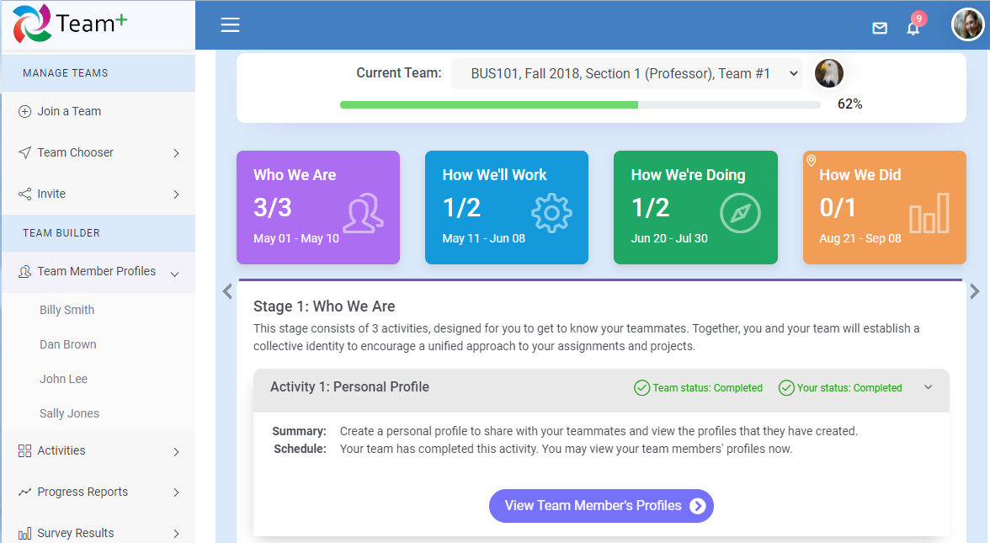
Team members’ photos and profiles are available to view
The team earns a completion status when an activity is completed
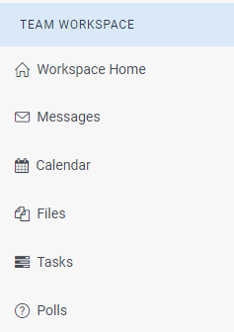
Organization and collaboration tools are available by opening the Team Workspace

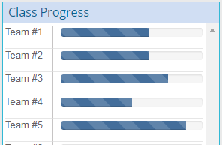
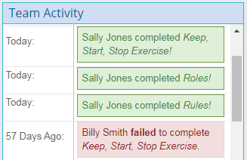

Team members can see who has (or has not) completed each activity
Teams can compare their progress to other teams in the class

Team Builder Activities

The Team+ website guides your student teams through eight activities carefully designed to help them develop effective teamwork skills and have a more positive, productive group-based experience. These brief but impactful activities will help your teams:

- Develop a sense of identity that promotes trust and team cohesion
- Examine their communication, listening, and conflict management styles
- Make critical decisions about how to communicate, adopt roles, and establish helpful ground rules
- Identify specific behaviors that will improve overall team performance
- Exchange performance-based feedback that promotes personal development, participation, and individual accountability

All information and resources necessary for your students to complete these activities are provided on the Team+ website. Additionally, students begin each activity by viewing a tutorial video that explains why the activity is important and how to complete it. The eight activities are completed in order, and most of the activities have a “window” of availability based on the schedule you create at the beginning of the semester. We recommend successful completion of the activities be tied to your course grading scheme.

For more specific information regarding the activities your teams will complete, see these pages:

Stage 1: Who We Are p. 8

- Activity # 1: Personal Profile.
- Activity # 2: Team Styles.
- Activity # 3: Team Identity.

Stage 2: How We’ll Work p. 9

- Activity # 1: Rules
- Activity # 2: Roles

Stage 3: How We’re Doing p. 10

- Activity # 1: Keep, Start, Stop
- Activity # 2: Mid-Semester Developmental Feedback

Stage 4: How We Did p.11

- Activity # 1: End-Semester Team Evaluations

Activities / Stage 1

STAGE ONE ACTIVITIES: WHO WE ARE
These activities accelerate the team forming stage, moving the group from “Me” to “We”

Activity # 1: Personal Profile
- Teammates share photos and interesting biographical information; posted on a rotating carrousel at the top of the team’s web page, this information helps teammates get to know one another and “break the ice”.

Activity # 2: Individual / Team Styles
- Members complete self-assessments that reveal communication, listening, and conflict management styles; feedback includes tips on how to work with others who have varying styles, which prepares them for working with the specific members of their unique group.
Goals

Activity # 3: Team Identity
- Teammates agree on a team name, motto, and mascot

A sense of team identity underlies a sense of purpose. Team members must see themselves as a team, and they should see their team as unique. The team coalesces around a unique team identity.
Instructional Suggestions
Sharing photos and personal information with teammates encourages trust and respect, and promotes team cohesion.

Members learn about their own (and others) Communication, Listening, and Conflict Management Styles—and how that can impact team functioning.

- Ask teams to share their team name, motto and mascot with the class; they should explain why they made these decisions

- Send a positive and optimistic note to each team regarding their team identity

- After reading the personal profiles of each student, send a brief note with a comment regarding something about that person you found interesting

- Let team members share their assessment results and discuss how that might impact team success

Activities / Stage 2

STAGE TWO ACTIVITIES: HOW WE’LL WORK
Teams will make critical decisions about how to structure interactions and function as a team

Activity # 1: Operational Rules
Teammates decide:
- How to communicate with one another outside of face-to-face team meetings (e.g., email, text messages, phone conferences, etc.)
- How often members agree to check for messages or contact team members
- The best type of team meeting (face-to-face or virtual) and how often the team will meet
- To adopt a set of basic ground rules that will guide their interactions during the semester

Activity # 2: Individual Roles
Members accept responsibility for specific tasks that will promote more efficient interactions and successful task completion; possible tasks include:
Goals
- Send reminders for upcoming meetings
- Develop and distribute meeting agendas
- Create a calendar of internal team deadlines for task deliverables
- Review/edit documents prior to final submission
- Remind teammates of their project responsibilities and assignment deadlines

Student teams will immediately focus on completing the classroom tasks you have assigned; they often fail to recognize the critical impact their own processes can have on their ability to function effectively.
Instructional Suggestions
The activities in this stage require teams to be proactive - to make decisions that will provide much needed structure to team processes so their interactions are more efficient and effective.

Expected outcomes of this stage include more effective meeting management skills, improved communication and collaboration, reduced interpersonal conflict, and personal accountability.

- Ask teams to share the results of these two activities with the class; after all teams have shared, look for common themes and discuss their importance to team functioning.

- Discuss specific ground rules adopted by the teams and why they were chosen. How will these rules impact team functioning?

- Ask team members to explain why they chose certain roles/tasks; how do they see these roles contributing to team success?

Activities / Stage 3

STAGE THREE ACTIVITIES: HOW WE’RE DOING
A structured activity that requires team to analyze their own performance
and make specific recommendations for improvement

Activity # 1: The Keep, Start, Stop Exercise
Teammates work together to identify:

- Specific behavior/processes that are helping the team (Keep)
  - For example – Everyone is checking Team+ daily for messages
- Specific behavior/processes that could help the team (Start)
  - For example – We should use an agenda in our meetings to help keep us on track
- Specific behavior/processes that are hindering the team (Stop)
Goals
  - For example – We tend to procrastinate, working right up to deadlines

Activity # 2: Mid-Semester Self/Peer Evaluations and Developmental Feedback
At mid-semester team members receive performance feedback from their peers. This represents a developmental opportunity for individuals to assess and improve their performance and relationships in a non-threatening context.

Student teams tend to focus on the current assignment, and the next due date – failing to examine how well they are working together, and how they could improve. We know that effective teams take the time to monitor their own processes, and answer the question – “How well are we doing so far?”
Instructional Suggestions
In these simple but impactful exercises, teams will examine their own behaviors and processes to identify what they are doing well, and how they can improve. The results encourage “mid-course corrections” that otherwise would be overlooked. We recommend the mid-semester result be used for developmental purposes, allowing the team members to make positive changes over the last half of the semester.

- Ask teams to share the results of their KSS Exercise with the class; after all teams have shared, look for common themes and discuss their importance to team functioning.

- As each team presents its results, discuss which issues it will address the rest of the semester, and how. Be specific.

- Students should comment on their mid-semester feedback; what was the most surprising result?

STAGE FOUR ACTIVITIES: HOW WE DID
Activities / Stage 4

At the end of the semester, teammates rate themselves (self-ratings) and one
another’s performance (peer ratings) on five factors critical for team success

Activity # 1: End-of-Semester Self/Peer Performance Evaluations and Feedback
Using the same rating process as before, these results should be tied to the student’s course grade

At both mid- and end- semester, self and peer ratings are completed for five “teamwork” factors:
- Acting Responsibly to the Team
- Creating a Positive Team Climate
- Making a Collaborative Effort
- Managing Conflict Inclusively and Constructively
Goals
- Monitoring Individual and Team Performance

For each factor, the student is presented with sample behaviors that reflect “Ineffective Behaviors,” “Acceptable Behaviors,” and “Most Effective Behaviors.” Students indicate what type of behaviors were displayed most often during the semester. Each student receives an individualized feedback report that compares self-ratings to the average peer rating.

Instructional Suggestions

Personal development and individual accountability are important in a team environment.
The end-semester evaluations promote individual participation and accountability as team members anticipate performance ratings that impact their course grades.

- How will students change their behavior based on feedback results? They should be specific.

- How will the results of end-of-semester ratings impact their behavior on future teams, both in school and the workplace?

Monitor Performance

You can easily keep track of the participation of individual students and
the performance of your student teams

THE INSTRUCTOR’S APP

With the unique Instructor’s App, you can instantly know how well your teams are progressing through the activities in Team+.

From the Instructor’s App you can view and download:

- Photos and biographical information for every team member

- Which team members successfully completed each Team+ activity
(and which have not!)

- The number of posts (contributions) each teammate made to the team discussion activities

- The actual content of every post made by all students

- Self and peer performance ratings resulting from the evaluation processes

All information and data can easily be downloaded as Excel spreadsheets for further analysis.

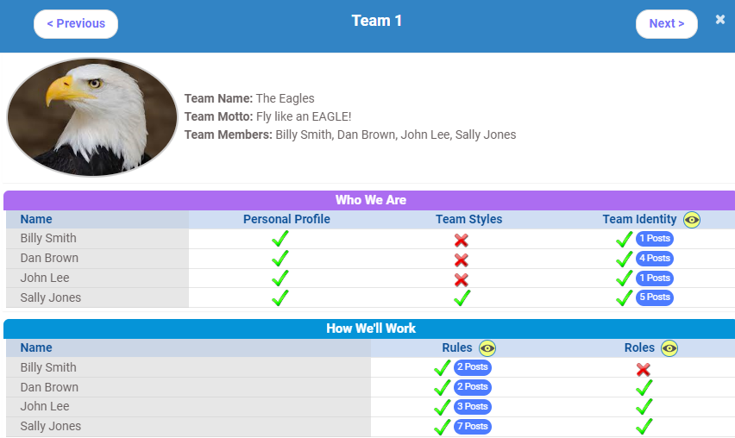
The Team Workspace includes a set of online collaboration and communication tools to make it easy to work together directly on the website.
Additional Features

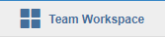

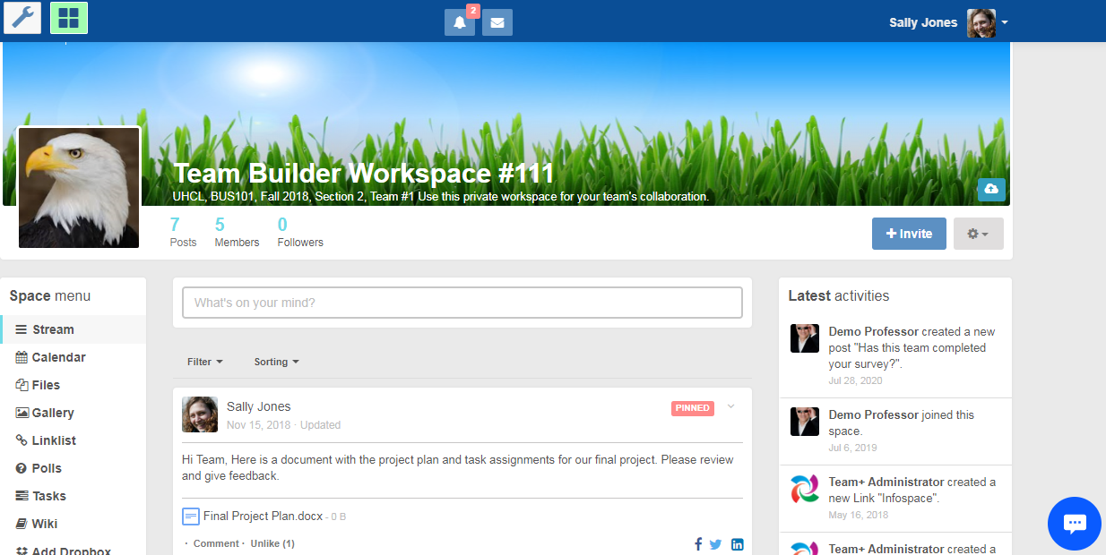
Videos to Improve Interpersonal Relationships

The Team+ System includes numerous “self-help” videos that address issues often found in student teams. These brief videos provide specific recommendations (what to say, what to do) that students / teams can apply immediately to improve relationships and overall team performance.

- Meetings Are Too Long, Nothing Gets Done

- Team Members Procrastinate / Miss Deadlines

- Dealing with Conflict Between Teammates

- One Teammate Dominates the Discussion During Team Meetings

- A Teammate is Not Speaking Up at Team Meetings

- A Teammate Won’t Do Their Part

- How to Offer Critical Feedback to a Teammate
Videos to Improve Difficult Team Situations

- How to Respond When a Teammate is Critical of You

- This is a Team – It’s Not Always About You

- Please Don’t Judge Me, Just Respect Our Differences

- Your Teammates Just Want You to Listen

- Problems with a Teammate? Talk to Them About It, But Be Nice

Make sure your teams are aware of these videos, and encourage them to preview each video for valuable information that can help them throughout the semester.

Better yet, show some of these videos in class and discuss their content.

